Prerequisite for Deployment.

1. Download Putty.exe.
2. Download WinSCP.exe.
3. Download Eclipse.
4. Configure SVN and CVS repository.

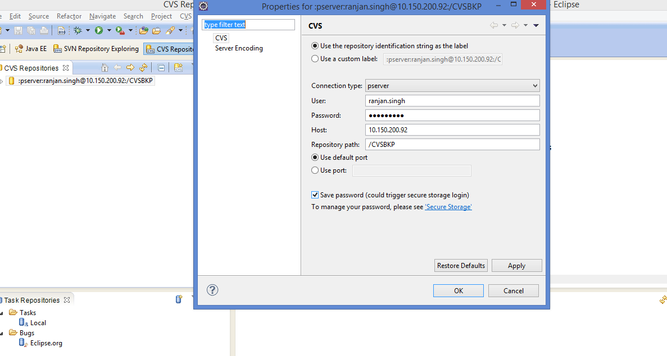

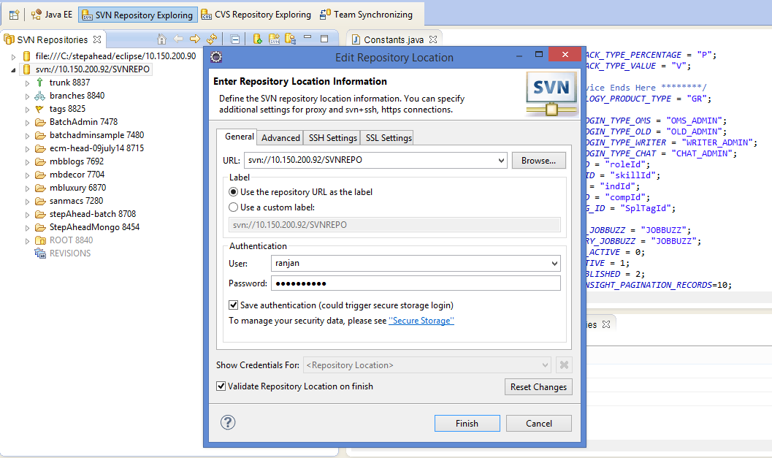

Putty Login:

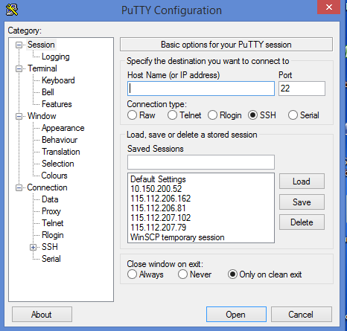

Enter server ip and click open.

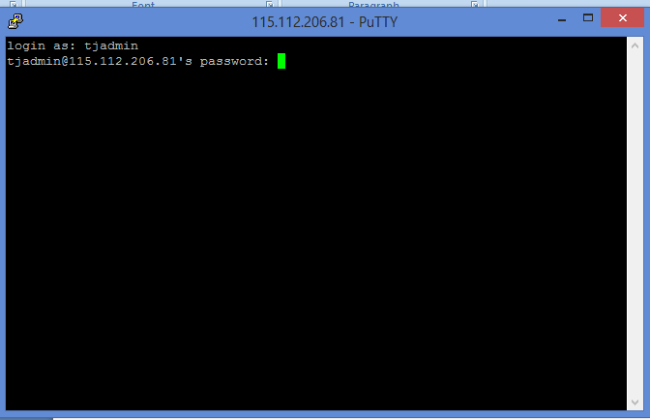

Enter login id and password.

For Winscp :

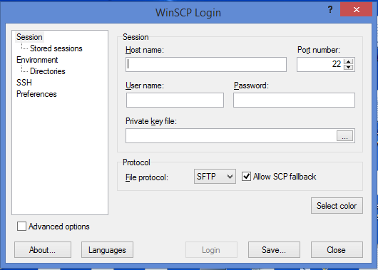

Enter server ip in host name

Enter server username and password press login.

Windows appear after login is :

